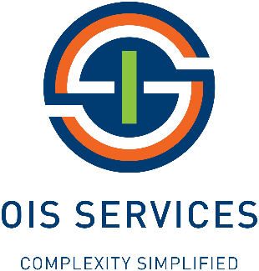
Accredited Diplomatic Visa – R1A

R1A – Accredited Diplomatic Visa is issued to accredited Diplomats to Nigeria. Eligibility for this visa type are accredited diplomats. This visa type grants applicant a diplomatic work permit of 2 years (renewable). Permitted activities are diplomatic activities work in Nigeria as accredited diplomat.
Tick when Completed
1 | APPOINTMENT: OIS Appointment booking for each applicant, please do not book more than 30 days before travel. Book your appointment at https://apt.oisservices.com/.
2 | TRAVEL DOCUMENTS: Diplomatic Passport with a minimum of 6 months validity at the time of travelling to and from Nigeria with two blank facing pages.  The mission will hold passport/Travel Documents until a decision has been made.  If non-Dutch/Netherlands passport holders, please see IMPORTANT INFORMATION below.
3 | PASSPORT SIZE PHOTOS: Two recent standard passport-sized photographs, taken no more than 2 weeks before submission, with the applicants full name written on the back.
4 | ONLINE APPLICATION FORM: Completed application form filled and paid for online at https://visa.immigration.gov.ng/.  Once completed this must be printed out, in portrait by applicant.
5 | ONLINE PAYMENT RECEIPTS: Payment receipt - Printed from https://visa.immigration.gov.ng/ after completion of payment.
6 | VALID PASSPORT DATA PAGE: Copy of Applicant valid diplomatic passport data page.  NOTE: It must be coloured copy with a full-page shown.
7 | LETTER FROM NIGERIA’S MINISTRY OF FOREIGN AFFAIRS: Provide a letter from Nigeria’s Ministry of Foreign Affairs.
8 | NOTE VERBAL FROM INVITER: Provide detailed NOTE VERBAL from Nigeria. The Note verbal must state the official position of applicant in the Embassy/Ministry of Foreign Affairs. Must be stamped and signed.
9 | NOTE VERBAL FROM EMPLOYER: Provide detailed NOTE VERBAL from your employer. The Note verbal must state the official position of applicant in the Embassy/Ministry of Foreign Affairs. Must be stamped and signed.
10 | STAFF ID CARD: Provide a copy of applicant staff ID Card (front and back). This must be printed out. Show original at sight.
11 | Flight Reservation
12 | Copy of the Yellow Fever Vaccine (strict requirement, except for medical exemption with proof).  Copy of the COVID Vaccine certificate (non-strict requirement, kindly provide if taken).

IMPORTANT INFORMATION (if applicable)
- ONLY APPLICANT APPLYING FOR VISA ARE ALLOWED INSIDE THE OFFICE

- APPLICANTS APPLICATION WILL NOT BE PROCESSED IF THEY DO NOT MEET UP WITH THE VISA REQIUERMENTS GIVEN IN THE VISA CHECKLIST

Please check our opening hours to avoid delays and for any additional information please call us on +31708915324 email us at infothehague@oisservices.com or visit our website www.oisservices.com

